Experiment 1:
Aim: Write a Pandas program to select the distinct department id from employees file.
Python code:
import pandas as pd
employees = pd.read_csv("employees.csv")
distinct_dept = employees["department_id"].drop_duplicates()
print("Distinct Department IDs:")
print(distinct_dept)
output:
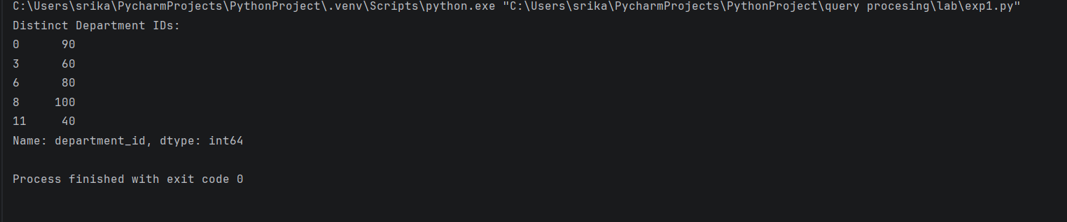
Experiment 2:
Aim: Write a Pandas program to display the IDs of employees who have done two or more.
Python code:
import pandas as pd
# Read job history
job_history = pd.read_csv("datasets/job_history.csv")
# Count number of jobs done by each employee
job_count = job_history.groupby("employee_id").size()
# Employees with two or more jobs
result = job_count[job_count >= 2]
print("Employees who have done two or more jobs:")
print(result.index)
output;
